Week 5 report of Internship

Ammar Akram
Name

DVS-8041
ID

Machine Learning
Domain

Ofiice
Devsphere

04/10/2026
Date

DEVSPHERE AI & ML INTERNSHIP

DevSphere AI & ML Internship — Week 5
Model Evaluation + Tuning
Optimize Machine Learning Model

1. Introduction:
Machine Learning model performance depends not only on training a model but also on accurately evaluating, comparing, and optimizing its performance.
The objective of this task was to train multiple classification models, evaluate their performance using standard evaluation metrics, compare their results, and apply hyperparameter tuning to improve model configuration.
For this task, the Breast Cancer Wisconsin Diagnostic dataset available through Scikit-learn was used. Three classification algorithms were evaluated:
- Logistic Regression
- Random Forest
- Support Vector Machine (SVM)

Random Forest was subsequently selected for hyperparameter tuning using GridSearchCV. The optimized model was evaluated on unseen test data using accuracy, precision, recall, F1-score, classification report, and confusion matrix.

2. Objectives:
The main objectives of this task were:

- Train multiple Machine Learning classification models.
- Compare model performance using evaluation metrics.
- Apply hyperparameter tuning using GridSearchCV.
- Evaluate the optimized model on unseen test data.
- Generate visualizations for model comparison and tuning results.
- Save the optimized Machine Learning model for future use.
- Prepare a complete evaluation report documenting the results.

3. Dataset:
The Breast Cancer Wisconsin Diagnostic dataset was obtained using Scikit-learn's built-in load_breast_cancer() dataset.
The dataset contains numerical measurements calculated from digitized images of breast mass samples. The classification task is to determine whether a tumor is malignant or benign.
Dataset Information:
Property | Value
Total Samples | 569
Features | 30
Training Samples | 455
Testing Samples | 114
Classification Type | Binary Classification
Target Classes | Malignant, Benign
Train/Test Split | 80% / 20%
Random State | 42
Stratification | Applied

The dataset was divided into training and testing sets using stratified sampling to maintain class distribution.

4. Data Preparation:
The following preprocessing and preparation steps were performed:

- Loaded the dataset using Scikit-learn.
- Separated features and target labels.
- Divided the dataset into training and testing subsets.
- Used stratification to preserve class distribution.
- Applied feature scaling where required.
- Used StandardScaler with Logistic Regression and SVM through Scikit-learn pipelines.
- Kept Random Forest unscaled because tree-based models do not require feature standardization.

5. Machine Learning Models:
Three classification models were trained and evaluated.
5.1 Logistic Regression:
Logistic Regression was used as a linear classification model. StandardScaler was incorporated into a pipeline to normalize the input features before classification.
5.2 Random Forest:
Random Forest is an ensemble learning algorithm that combines multiple decision trees to produce a final prediction.
- The initial Random Forest configuration used:
- Number of estimators: 200
- Random state: 42
5.3 Support Vector Machine:
Support Vector Machine with an RBF kernel was used to classify the dataset. Feature scaling was applied before training.

6. Model Performance Comparison:
The trained models were evaluated using four major metrics:

- Accuracy
- Precision
- Recall
- F1-Score

Results:
Model | Accuracy | Precision | Recall | F1-Score
Logistic Regression | 98.25% | 98.61% | 98.61% | 98.61%
Random Forest | 95.61% | 95.89% | 97.22% | 96.55%
SVM | 98.25% | 98.61% | 98.61% | 98.61%

The comparison shows that Logistic Regression and SVM achieved the highest overall performance among the three initial models, while Random Forest also achieved strong classification performance.
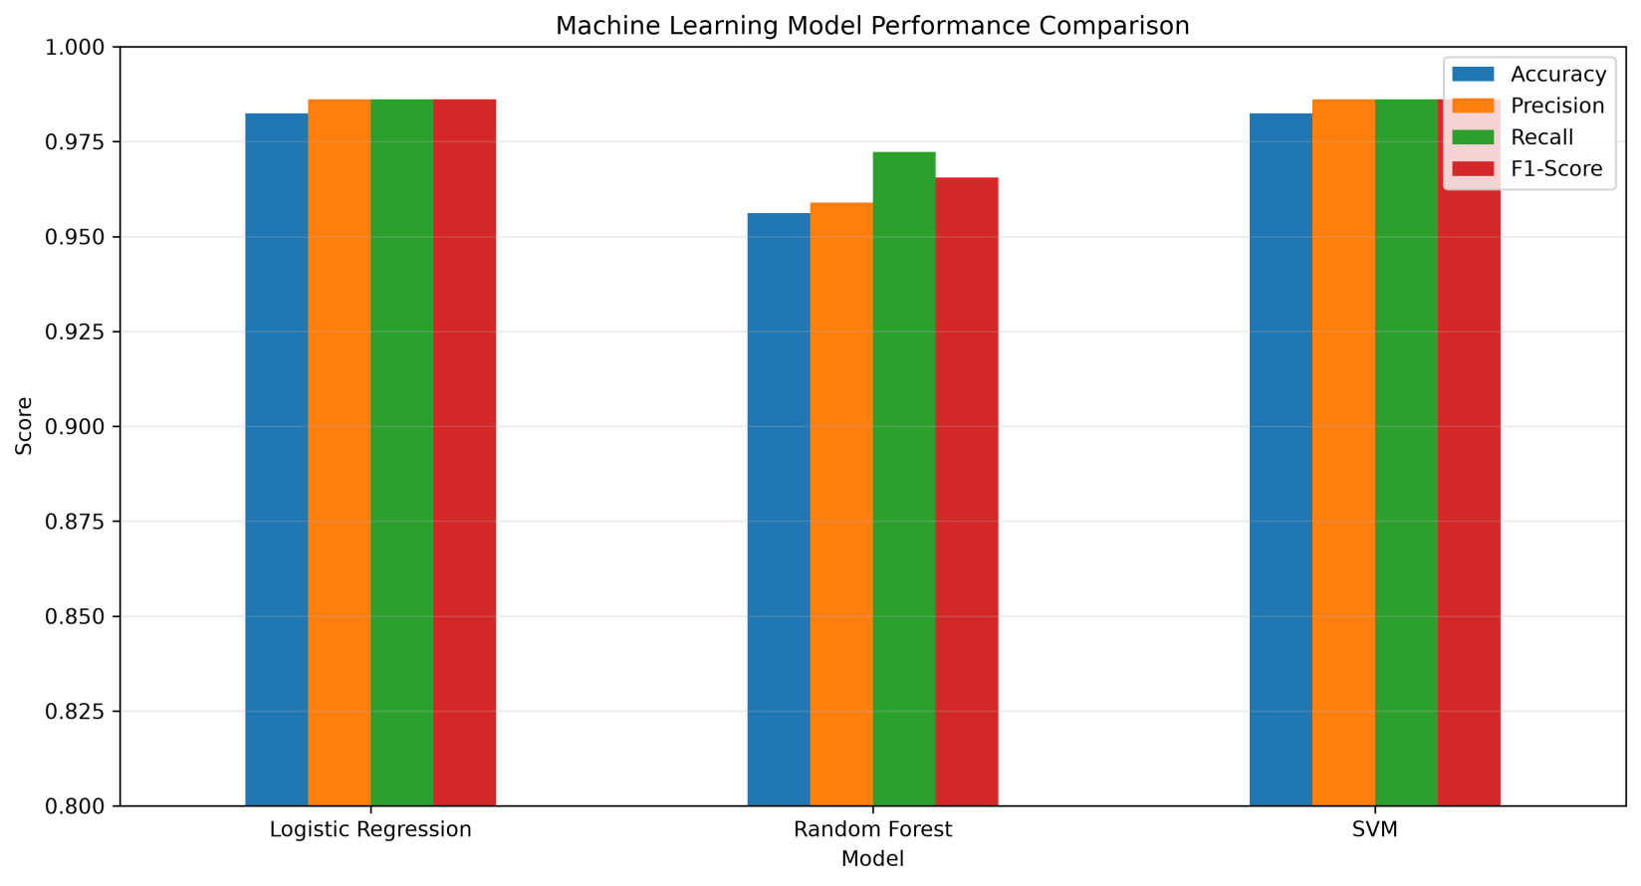

7. Model Evaluation Metrics:
Accuracy:
Accuracy represents the proportion of correctly classified samples among all test samples.
It provides an overall measurement of classification correctness.
Precision:
Precision measures how many samples predicted as positive were actually positive.
A high precision value indicates fewer false-positive predictions.
Recall:
Recall measures how many actual positive samples were correctly identified.
A high recall value indicates fewer false-negative predictions.
F1-Score:
F1-score is the harmonic mean of precision and recall. It provides a balanced measure when both precision and recall are important.

8. Hyperparameter Tuning:
To optimize the Random Forest model, GridSearchCV was used.
GridSearchCV systematically evaluates different combinations of hyperparameters using cross-validation and identifies the configuration that produces the strongest validation performance.
The following parameter combinations were tested:
Hyperparameter | Values Tested
n_estimators | 100, 200, 300
max_depth | None, 5, 10
min_samples_split | 2, 5
Cross-validation | 5-fold
Scoring Metric | Accuracy

A total of multiple parameter combinations were evaluated using 5-fold cross-validation.

9. Tuning Results:
The GridSearchCV process identified the best Random Forest configuration based on cross-validation accuracy.
The optimized model was then retrained using the selected configuration and evaluated on the unseen test dataset.
The tuning process demonstrated how systematic hyperparameter optimization can be used to evaluate different model configurations instead of relying solely on default parameters.
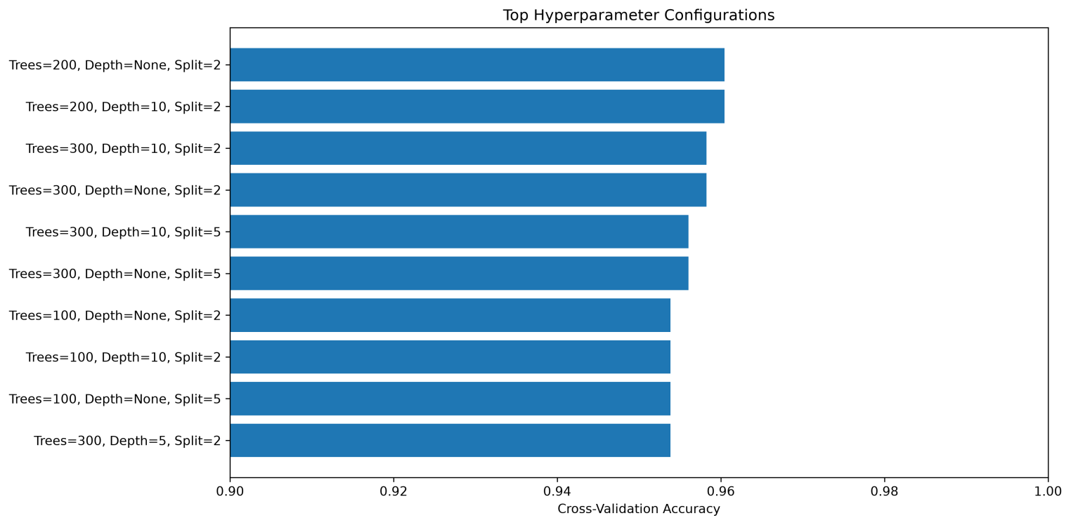
10. Optimized Model Evaluation:
The optimized Random Forest model was evaluated on the test dataset.
Final Test Results:
Metric | Score
Accuracy | 95.61%
Precision | 95.89%
Recall | 97.22%
F1-Score | 96.55%

The optimized model demonstrated strong performance across all evaluation metrics.
The recall score of 97.22% indicates that the model successfully identified the majority of positive cases in the test dataset.
The F1-score of 96.55% demonstrates a strong balance between precision and recall.

11. Classification Report:
The optimized Random Forest model was further evaluated using Scikit-learn's classification report.
The classification report provides class-level precision, recall, F1-score, and support values, allowing more detailed evaluation of the model's behavior across both target classes.
The results confirm that the optimized model maintained strong classification performance across the test dataset.

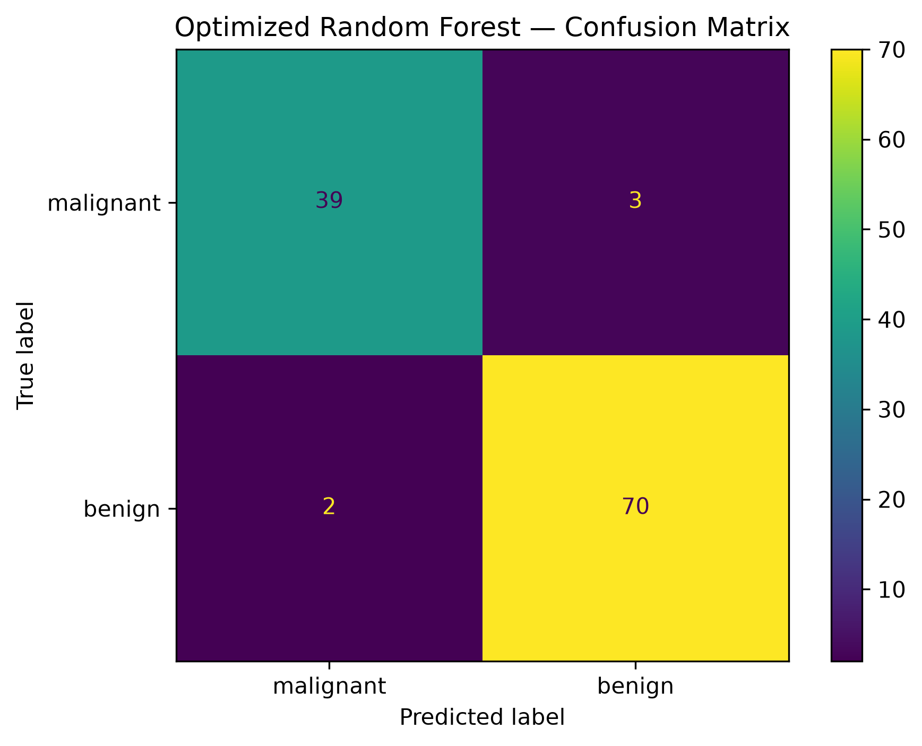
12. Technologies and Libraries:
The project was implemented using Python and the following libraries:

- Python
- NumPy
- Pandas
- Scikit-learn
- Matplotlib
- Seaborn
- Joblib
- Jupyter Notebook

16. Conclusion:
This task successfully demonstrated the complete process of Machine Learning model evaluation and tuning.
Three different classification algorithms were trained and compared using accuracy, precision, recall, and F1-score. Logistic Regression and SVM achieved the highest baseline performance, while Random Forest provided strong classification results and was selected for systematic hyperparameter optimization.
GridSearchCV was applied to evaluate multiple Random Forest configurations using 5-fold cross-validation. The resulting optimized model achieved 95.61% accuracy, 95.89% precision, 97.22% recall, and 96.55% F1-score on the unseen test dataset.
The task successfully fulfilled the requirements of model comparison, performance evaluation, hyperparameter tuning, visualization, and optimized model saving.

